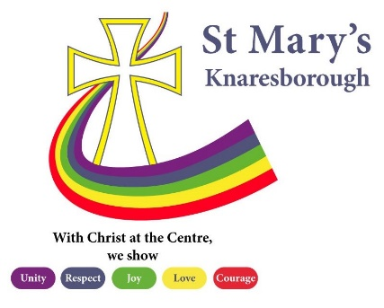

School performance data Summer 2023
We are proud of all our pupil’s achievements and progress during all the national assessments and in their time at St Mary’s. Below are details of our school performance at all key stages with comparisons to the national average.

EYFS

Expected or above | EYFS GLD
St Mary’s | 76%
National - 2022 | 65%

Year 1 Phonics

Expected or above | Year 1 Phonics
St Mary’s | 87%
National - 2022 | 75%

Key Stage 1

Expected or above | Reading | Writing | Maths
St Mary’s | 50% | 58% | 63%
National 2022 | 67% | 58% | 68%
St Mary’s Greater Depth | 17% | 8% | 13%
National 2022 | 18% | 8% | 15%

Year 4 multiplication check
*No pass mark set by DfE. Early indication of national average 20/25
Expected or above | Y4 MTC
St Mary’s | 12 pupils achieved 20 or above
National | No data currently

Key Stage 2
Expected or above | Reading | Writing | Maths | SPaG
St Mary’s | 60% | 59% | 57% | 60%
National 2023 | 73% | 71% | 73% | 72%
St Mary’s Greater Depth | 30% | 0% | 7% | 20%
National 2022 | 28% | 13% | 22% | 28%

Average KS2 Scaled Scores

 | School | National
Reading | 103.4 | 105
Maths | 100.7 | 104
GPS | 101.4 | 105

Science KS2
Expected or above | Science
St Mary’s | 83%
National 2022 | 79%

Reading, Writing and Maths combined
Reading, writing, maths combined | KS1 | KS2
St Mary’s expected or above | 46% | 43%
National expected or above 2023 | 65% | 59%
St Mary’s Greater Depth | 4% | 0%
National Greater Depth 2022 | 11% | 7%

There were no formal assessments in 2019-20 and 2020-21 due to Covid-19.
TO COMPARE US TO OTHER SCHOOLS, please follow the links: Bishop Wheeler Catholic Academy Trust - https://www.compare-school-performance.service.gov.uk/multi-academy-trust/2342/the-bishopwheeler-catholic-academy-trust?tab=primary

